**TASK REPORT**

**ALGORITHMS AND DATA STRUCTURE**

**WEEK 4**

**Created by:**

**Onic Agustino**

**L200234275**

**X**

**INFORMATICS ENGINEERING**

**FACULTY OF COMMUNICATION AND INFORMATICS**

**UNIVERSITAS MUHAMMADIYAH SURAKARTA**

**2024/2025**

**TASK**

1. **Write a Python program to find the longest word in a given String.**

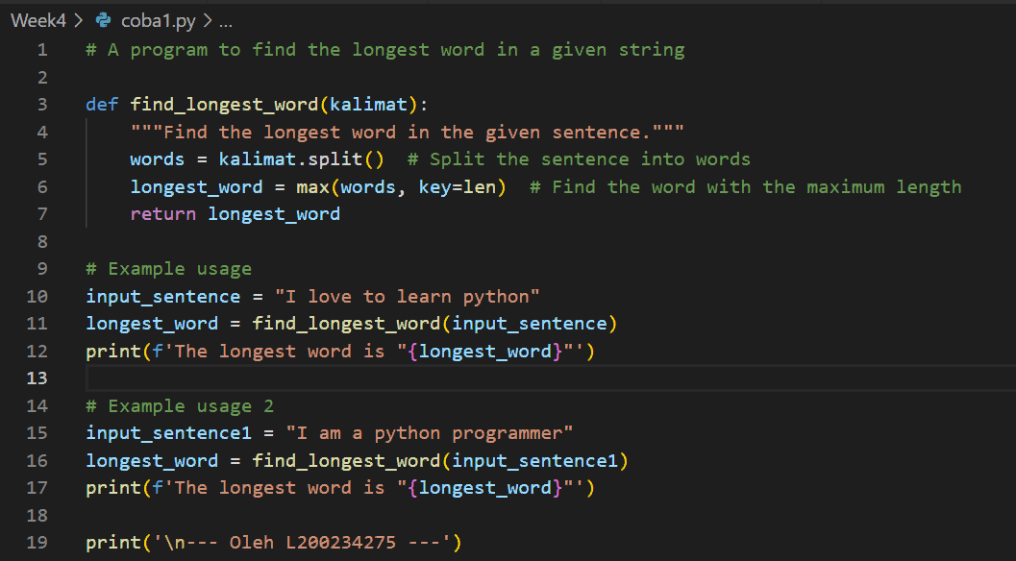

Picture 1.1 the code.



Picture 1.2 the output.

1. **Write a Python program to find one missing number in a given array of numbers between 1 and 10.**

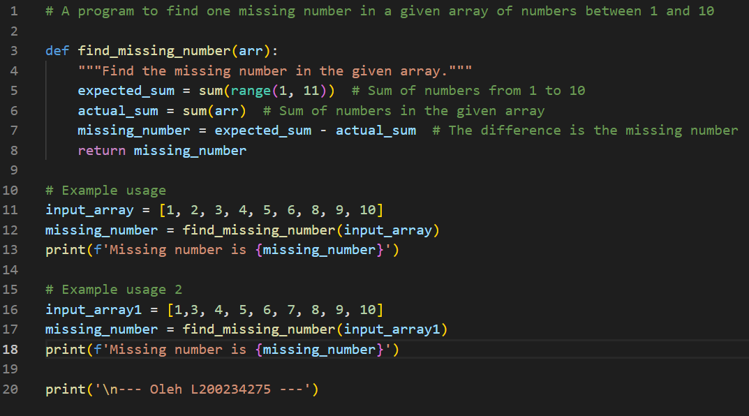

Picture 2.1 the code.



Picture 2.2 the output.

**Letcode**

1. [**Longest Word in Dictionary**](https://leetcode.com/problems/longest-word-in-dictionary/)

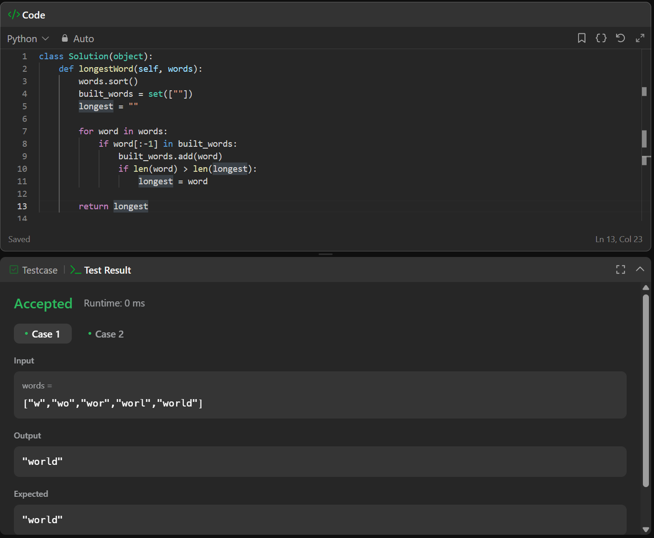

1. **Missing Number**

